23rd March 2020
Dear All,
I hope that this letter finds you well and that you are doing as well as can be expected in these unprecedented times.
Needless to say, we are here to support you. If you have any difficulties (financial / logistical / emotional…) please give us a ring. We will do all we can to help you.
We will be phoning around families to check on your well-being and on how your children are getting on. I have told the children that if they are feeling low, or if they just need to hear a friendly voice, to phone the school and have a chat.
Regarding home learning for the children, as you are aware each child from Ruby & Sapphire class have been allowed to take home their school Chrome Books to access our ‘Google Classroom’ where school work is being set. I am now pleased to inform you that each child from Diamond and Topaz class have now been assigned a Google account which will enable all families to access daily work on-line via your home computers. Please see the attached instructions on how to access these accounts.
From tomorrow (Tuesday 24th March 2020) work will be set in maths and English every day (by 8:30am) on the Google Classroom for all of our pupils. Some of the will need to be ‘turned in’ for the Teachers to mark, BUT most work will be self-marked and mark schemes will be available, children will be used to self-marking. Explanations on expectations and details of any work needing to be submitted will also be on Google Classroom. Some work required the children to ‘turn in’
Staff will also be giving you links for websites and learning ideas. If you are looking to support children more, you can never go wrong by reading and learning times tables & number bonds!
Should you experience any technical issues please email the school office on office@bishopscaundle.dorset.sch.uk. However, if you have work related issues, please email as follows:
- Diamond & Topaz Classes: KS1@bishopcaundle.dorset.sch.uk
- Ruby Class: sarah.barnes@bishopscaundle.dorset.sch.uk
- Sapphire Class: chris.grant-peterkin@bishopscaundle.dorset.sch.uk

From today, we will also be operating a library service for reading books and other school resources. These will be given out via the office window. All resources will be collected and signed for and should be returned before collecting more. Our school resources are vital to us providing an effective service, as such, if resources are damaged or not returned we will unfortunately have to charge you. If you would like to utilise this service, please

Cont…/2

mail the school office on office@bishopscaundle.dorset.sch.uk giving 24hrs notice so that we can prepare the suitable packs for your child(ren)
Finally, a bit of advice:
- Stick to a strict structure with plenty of breaks
- Incorporate physical activity
- Find a quiet space to work.
- Set Realistic Goals and Create a Support System
- Get Dressed Every Day
- Keep the Kids Busy in the Morning. ...
- Be Flexible
- Make Daily To-Do Lists. ...
- Schedule and limit social media time

Take care,

Nigel Roberts
Headteacher

Accessing Google Classroom

Step 1: Open up the internet on internet on Google Chrome

Step 2: Go to ‘Log in’ – top right of screen

Step 3: Login with:
Username = firstname.surname@bishopscaundle.dorset.sch.uk
Password = Password (please help them to change this)

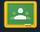
Step 4: Open up Google Classroom
Click on the green rectangle framed in yellow (google classroom)

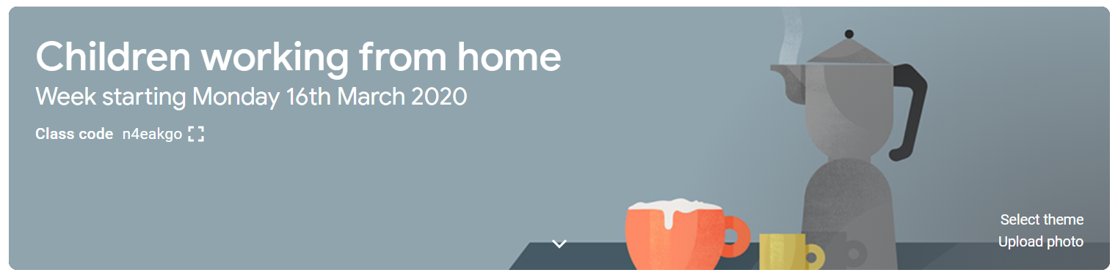
Step 5 Home learning
Home learning will be set in the google classroom called ‘Children working from home’. Should the whole school close a new ‘Children working from home’ classroom will be set up each week.
Stream channel - This is where you will see daily and/or weekly updates from your class teacher.
Classroom channel - This is where the home learning is located. It is divided into days of the week. There is also a section for work that needs to be completed daily.

PLEASE REMEMBER THAT MOST OF THE WORK SET WILL NEED TO BE SELF MARKED FROM THE MARKING GUIDES THAT WILL BE ATTACHED

