Diamond Class  Summer Term 2019 | 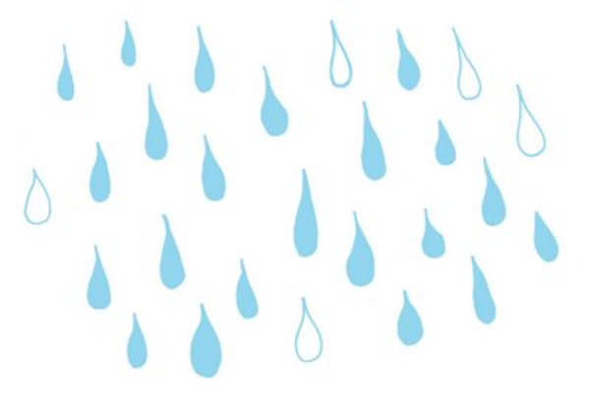  Splish Splash Splosh!
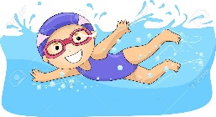  Marvellous Middle: Swimming season!  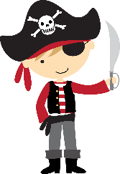  This Photo by Unknown Author is licensed under CC BY-NC  Fabulous Finish:  Pirate Day - 16th July. We welcome children to dress up for the day and would like to invite parents/carers to join us from 3.00pm to look at outcomes and books with their “pirates” in class! | Science  Our learning in Science will look at animals, including humans. There will be an enquiry focus on categorising and grouping. The children will learn about the structure of a variety of animals and be able to associate these with the key terms: carnivore, omnivore, herbivore.
OUTDOOR LEARNING  Please bring clothes to access the Forest School area in a named bag ready to change into at break time on the following days:  RECEPTION – Tuesday 30th April & Tuesday 7th May  YEAR 1 – Tuesday 14th May & Tuesday 21st May  We ask kindly for you to ensure that these are weather appropriate including suitable footwear for exploring and climbing, a sunhat etc. | Geography  We will continue to look at the continents and seas, learning their names and locations whilst linking this to sea voyages that have been made.  The vocabulary that we will focus on applying this term will refer to key physical features such as:  beach, cliff, coast, sea, ocean, river, valley, season and weather.
Maths

Year 1
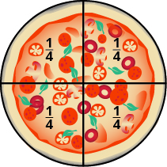
This term we are continuing our learning about multiplication using 2s, 5s and 10s. We will then reverse this to look at methods of division, recognising this as the opposite to multiplication.
For example, if we know that 5 x 3 = 15 (5 groups of 3 equals 15) then we will be able to take 15 and divide/share it into 3 groups with 5 in each group.

Linking to division, the children will explore how to use the fractions ½ and ¼ when considering both shapes and quantities. They will learn that they are taking 1 whole and splitting it into 2, or 4 equal parts.

To finish the term we will revisit how to solve a missing number problem for addition and subtraction, e.g. 16 - __ = 9.

Reception

The focus on learning this term will be based around the concepts of sharing, halving and doubling. The children will learn to create groups of objects to help them to solve problems. They will begin to count in 2s, 5s and 10s as they do so.
For example, “there are 4 fields and 8 sheep. How many sheep will go in each field to make each field equal?”

The children will also revisit using both objects and a number line to subtract and add two single digit numbers.

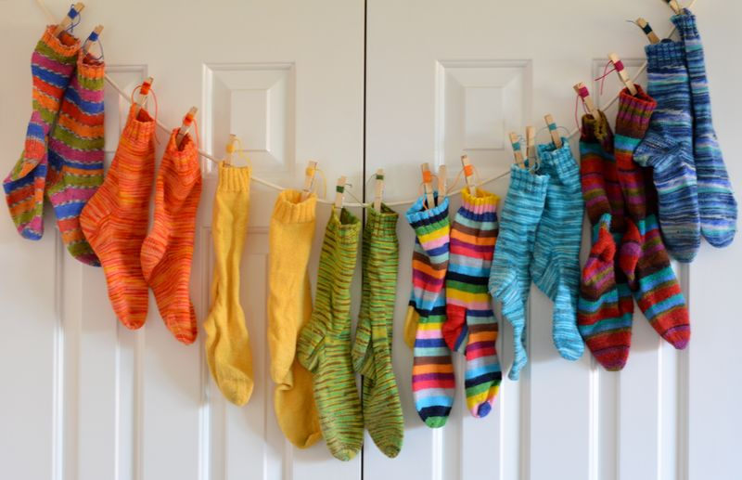
This Photo by Unknown Author is licensed under CC BY-NC

English

The children will use their science knowledge about animals to create a fact file about a sea creature. They will build on their knowledge of non-fiction from last term to show how to create something that is visually appealing, and which includes facts rather than opinions.
They will use the text “Commotion in the Ocean” as a basis for their poetry as they explore, comprehend and innovate their own poems. This will be a fabulous opportunity for playing with words that rhyme and understanding that some poems read sensibly whereas others will be nonsense!
Whilst reading the texts Tiddler and The Snail and The Whale, the children will focus on descriptive writing of settings and characters. This will lead to them writing their own sea adventures! Year 1 children will be encouraged to compare these two texts that are written by the same author to find similarities and differences, as well as express their own opinions about these.
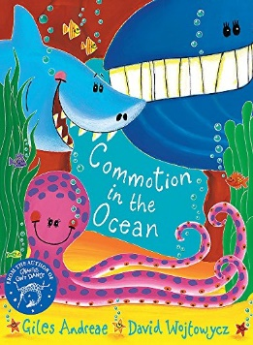
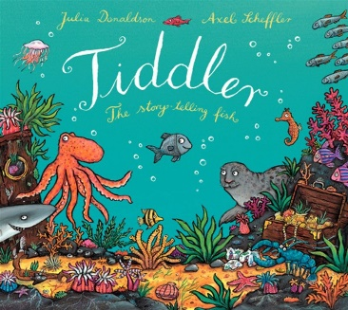
We will be reading:
This Photo by Unknown Author is licensed under CC BY-SA-NC
Tiddler by Julia Donaldson
Jack and the Flum Flum Tree by Julia Donaldson
Commotion in the Ocean by Giles Andreae
The Snail and the Whale by Julia Donaldson
Spellings:
Year 1 – Children must continue to practise the spellings of the Common Exception Words that were sent home before the Easter break. The expectation is for these to be secure by the end of Year 1.
They will also be looking at the spellings of numbers (as words) from zero to twenty, and the days of the week.

PE
RE
The focus for R.E. this term will be on Judaism. We will look at the importance of Shabbat, Rosh Hashanah and Yom Kippur to Jewish children.

PE will continue to be on a Wednesday afternoon and a Friday this half term. This will cover ball skills and athletics.
Swimming will begin after the May half-term where children will have a daily swimming session in our heated, outdoor pool. It’s our favourite time of year!

DT  Children will be exploring the concept of floating and sinking. They will be challenged to create their own boats, which we will test to see how well they float. Through this we will be recapping the Science work that happened in the Autumn Term as we think about the properties of materials. | Art  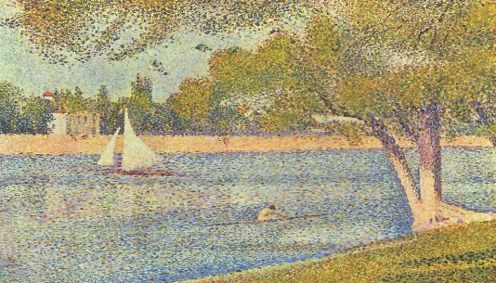  Art sessions will include a focus on the skill of printing after looking at the work of Seurat.  This Photo by Unknown Author is licensed under CC BY-ND  We will also be sculpting with clay to create our own sea creatures, thinking carefully about our science learning as we do this to ensure that the parts of the animal’s body are clearly represented.
Music
Exploring the sounds of unused instrumetns will enable children to begin composing their own “under the sea” themed music this term. They will consider how instruments can be played to create different sounds.

Key Dates

- Friday 3rd May 3:00pm – Phonics Screening Meeting for Year 1 parents
- Swimming begins on Tuesday 4th June 2019 – A letter detailing information about this will be sent to the whole school nearer the time.
- Phonics Screening Check week for Year 1 – Week beginning 10th June 2019
- Stay & Play – We would like to invite you for another Stay & Play session this term. Come and join us on either Monday 17th June (1:30pm-2:45pm) or Tuesday 18th June (9:15am-10:30am). More details will follow nearer the time.
- Pirate Day 16th July – children to dress up for the day. Parents invited in from 3.00 to look at outcomes and books with children in class.

