All Saints CE VC Primary School

Online Safety Newsletter: November 2019

Threads

This new app by Instagram launched last month, it’s a standalone camera app rated 12+ on the App store. It has been designed so users can keep up to date with their ‘close friends’ (close friends list set up on Instagram). It allows users to easily send images and chat directly to their ‘close friends’.

It’s different from Instagram in that you do not have a feed and you can only send messages, view stories and add a real time status (auto status). If you allow Threads to access your location, it will use this to auto update your status, so for example if you’re moving in a car, it will add a car icon or at home, add a house icon. It does not provide locations on a map.

You should be aware that whilst this app is aimed at communicating between ‘close friends,’ your child could be communicating with people they do not know in real life.

More information is available here:
https://instagram-press.com/blog/2019/10/03/introducing-threads/
Mixer

Mixer is owned by Microsoft and available on iOS (rated 17+), Android platforms, through the Mixer website, Xbox One and Windows PC. Streamers can broadcast game footage, live events, and interact with each other via online chat. It has similarities to Twitch.

Parents should monitor what their children are viewing on this app because they could be watching gamers playing games that are inappropriate for their age e.g watching somebody play Call of Duty, which is 18+. They may be watching games that contain sexual content, violence and explicit language. In addition, due to the chat facility, they may hear or be subjected to inappropriate language.

Mixer gives streamers the option to state that their channel is for 18+, which means that the streamer is stating the channel is not suitable for children but Mixer state that it is up to parents to check what their child is watching.

In app purchases: Mixer have their own in game currency called ‘embers’ which are available to purchase from 99p – to £199.99 and can then be used to purchase stickers or further effects. Make sure credit card details are not stored on any devices.

More information is available here: https://www.commonsensemedia.org/app-reviews/mixer
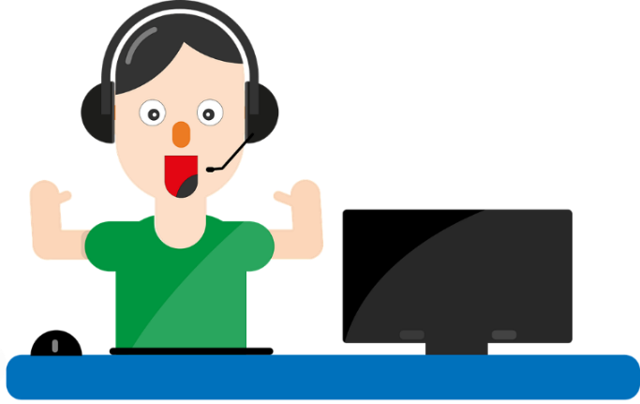

Tiktok
Memoji

Have you set up your Memoji yet? It’s Apple’s version of a Bitmoji on Snapchat or AR Emoji on Samsung and allows you to create a cartoon version of yourself and then animate it.

What is TikTok? Users can watch musical clips, record 60 second clips, edit them and add special effects. You must be over 13 years of age to use Tik Tok. You need to be aware that some of the songs used in this app may contain explicit language and sexual imagery, which may not be suitable for your child to view.

We recommend that users have a private account to control who can see their videos, follow them and who can send them messages. Even with a private account, your child’s profile information such as their photo and bio is still visible to all so ensure your child understands the importance of not revealing any personal information such as address, age and phone numbers in these areas.

As with similar apps, there is the ability to report and block other users so ensure your child knows how to use the reporting features within this app and is able to block other users if necessary so that that user cannot see their content or send them messages. Tik Tok also includes a ‘Restricted mode’ to limit the appearance of content that may be inappropriate.
Focus on CBBC

The CBBC site is an amazing resource for children and parents including age appropriate games, quizzes and news stories.

Available here:
https://www.bbc.co.uk/cbbc

Finally, Tik Tok (along with other apps) has been used recently for a social media challenge (e.g. Lip challenge). We do not recommend talking to your child about specific challenges (it draws attention to them) but we do recommend talking to your child about challenges as a whole that may appear on the internet and making sure they know that they can talk to you about what they see online. Talk to them about the potential risks that may arise from participating in such challenges.

Further information can be found here:
- https://parentzone.org.uk/article/tiktok-everything-you-need-know-about-video-production-app
- https://www.commonsensemedia.org/blog/parents-ultimate-guide-to-musically
- http://support.tiktok.com/?ht_kb=for-parents

Top tip

Has your child set their Instagram profile to private? It’s what we recommend but remember that people searching for your child’s account can still see their photo and bio info so check that they’ve not included any personal information in there.

