All Saints Primary School  Rubies Class |  |  |  | Cross Curricular Links to Support Learning
 |  |  |  | Art and DT
 |  |  |  | Rubies Art and DT will all be related to their topic on WW2. In Art we will be looking at posters from WW2 such as ‘make do and mend’, ‘dig for victory’ and ‘careless talk costs lives’ and designing our own eye-catching posters using a variety of media. In D.T. we will be making gas mask boxes, designing, making and evaluating our own models of air raid shelters before working with Sapphire class to build our own air raid shelter. In cooking we will be using ingredients from ration books to cook!
World War 2 |  | Books and Authors |  | Geography
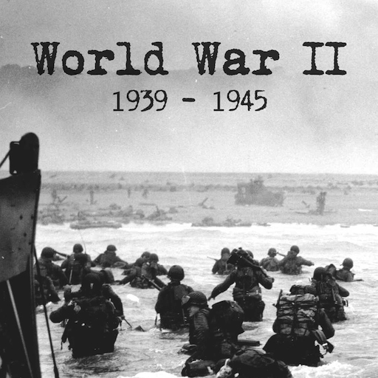 |  | We will be reading:  The Lion and the Unicorn – Shirley Hughes  War Boy - Michael Foreman  Story Telling story about - heroes |  | The children will develop their locational knowledge by naming and locating countries and cities involved in WW2. They will create their own fact file about one of the countries located.
 |  |  |  | Word Mechanics and Super Skills
Children will be developing their spelling strategies by revising the use of suffixes and prefixes and learning a new spelling rule each week.
Additionally, they will learn about word classes, grammar and punctuation to apply to their own writing. For example: conjunctions, preposition, apostrophes and expanded noun phrases.
Each week children will read within a small group, with the teacher, interpreting and making inferences about a variety of texts. Each session will have a different focus allowing pupils to comment on the writer’s use of language and use strategies to predict, interpret and summarise.
At the beginning of this term Rubies will be working hard to improve the accuracy and fluency of their handwriting.

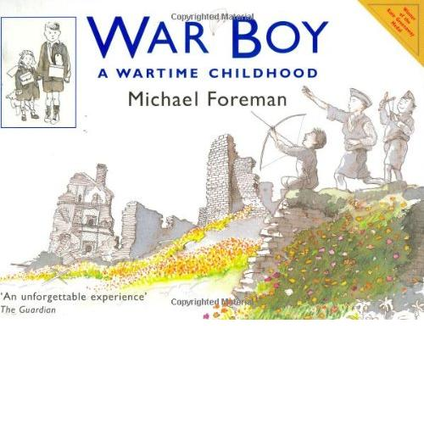
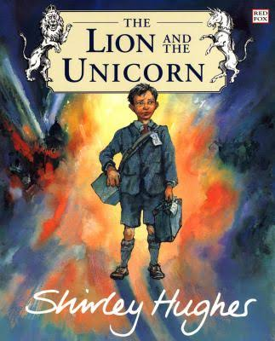

English | Mathematics |  | Science |  | French
We are beginning the term by looking at the story of The Lion and the Unicorn by Shirley Hughes. This story is about a Jewish boy called Lenny who is evacuated from London to the countryside. We will be using this as a stimulus for writing letters, descriptions and developing our own ideas for events that could take place within the story.  We will also be undertaking some work on story telling which will ultimately involve the children writing their own story about a fictional hero.  The topic of WW2 will provide many opportunities for non-fiction writing such as writing instructions for making air-raid shelters and recipes using only food available on ration. They will write fact-files about countries involved in WW2 and write their own diaries. | Every morning the children will continue to complete Quick Maths to practise the number and fluency skills for their Maths Passports.  This term Rubies will be learning about place value of 3 and 4 digit numbers. They will learn to order and compare numbers and place them accurately on a number line.  Rubies will be learning to add and subtract numbers using formal written methods of column addition and subtraction. They will also estimate the answer to a calculation and use the inverse operation to check answers and develop their reasoning skills.  We will be focussing on shape looking at symmetry and features of 2D and 3D shapes.  They will also complete a weekly problem solving activity to apply their skills learning into real life contexts.  I will be asking for your help to learn multiplication tables throughout the term and providing maths games to be played at home. |  | Light  Rubies will be learning to:  Recognise that they need light in order to see things and that dark is the absence of light  Notice that light is reflected from surfaces.  Recognise that light from the sun can be dangerous and that there are ways to protect their eyes.  Recognise that shadows are formed when the light from a light source is blocked by an opaque object  Find patterns in the way that the size of shadows change.  They will then undertake an investigation to discover which material would be most effective for a black out blind.  Plants  Rubies will be learning to:  Identify and describe the functions of different parts of flowering plants: roots, stem/trunk, leaves and flowers.  Explore the requirements of plants for life and growth (air, light, water, nutrients from soil, and room to grow) and how they vary from plant to plant.  Investigate the way in which water is transported within plants.  Explore the part that flowers play in the life cycle of flowering plants, including pollination, seed formation and seed dispersal.  We will be exploring plants whilst discussing the importance of dig for victory in WW2 and the Land Girls. |  | Rubies will be learning French with Mrs Crumpler each Wednesday morning this will be a fun and interactive introduction to the language.
 |  |  |  |  | RE and PSHE
This term Rubies will explore Judaism through the question ‘How special is the relationship Jews have with God?’
Leading up to Christmas they will explore ‘What is the most significant part of the Nativity story for Christians today?’
In PSHE Rubies will examine the theme ‘New Beginnings’, setting themselves targets for the year.
PE |  |  | Computing |  | Music
In PE the children will be developing PE skills in gymnastics and learning some dances from WW2.  The children will continue to have a weekly lesson outside learning tag rugby, football and basketball with Mr Noyce. |  |  | The children will begin the term by looking at how to keep safe on the internet. We will then be using programming to ‘programme tanks’!  Additionally, children will be using the internet to research countries to develop a fact file on a country involved in WW2 and using online resources to support their learning such as MyMaths. |  | The children will have the opportunity to listen to and learn a variety of music from WW2 and write their own lyrics to some well-known tunes.  